**Data Structures Lab 6 Report**

Group members: Vivek Kunapareddy, Yuan Cheng

**Objectives/Concepts:**

The concepts explored in this lab assignment were data structures, specifically stacks and queues. By building stacks and queues ourselves, it gives us a deeper understanding of the data structures and allows us to implement them effectively in a professional setting.

Since stacks and queues are used widely in design and analysis of algorithms, it’ll help us in technical interviews as well

It also helped us understand the game of Towers of Hanoi.

**Task 2:**

Screenshot of selecting number of disks:

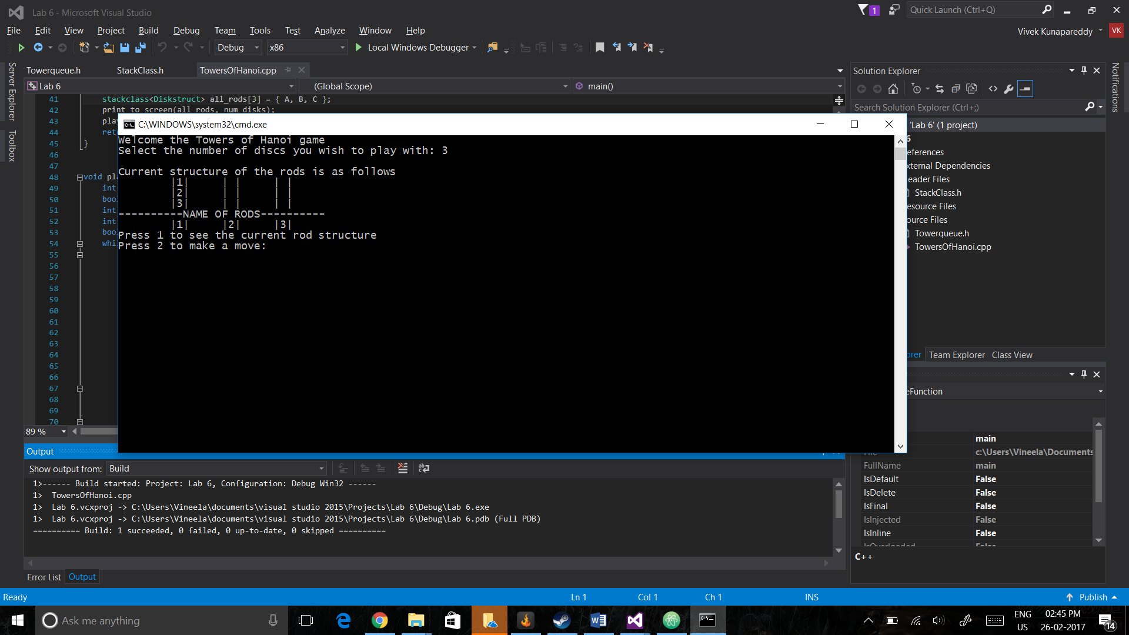

Screenshot of making a move:

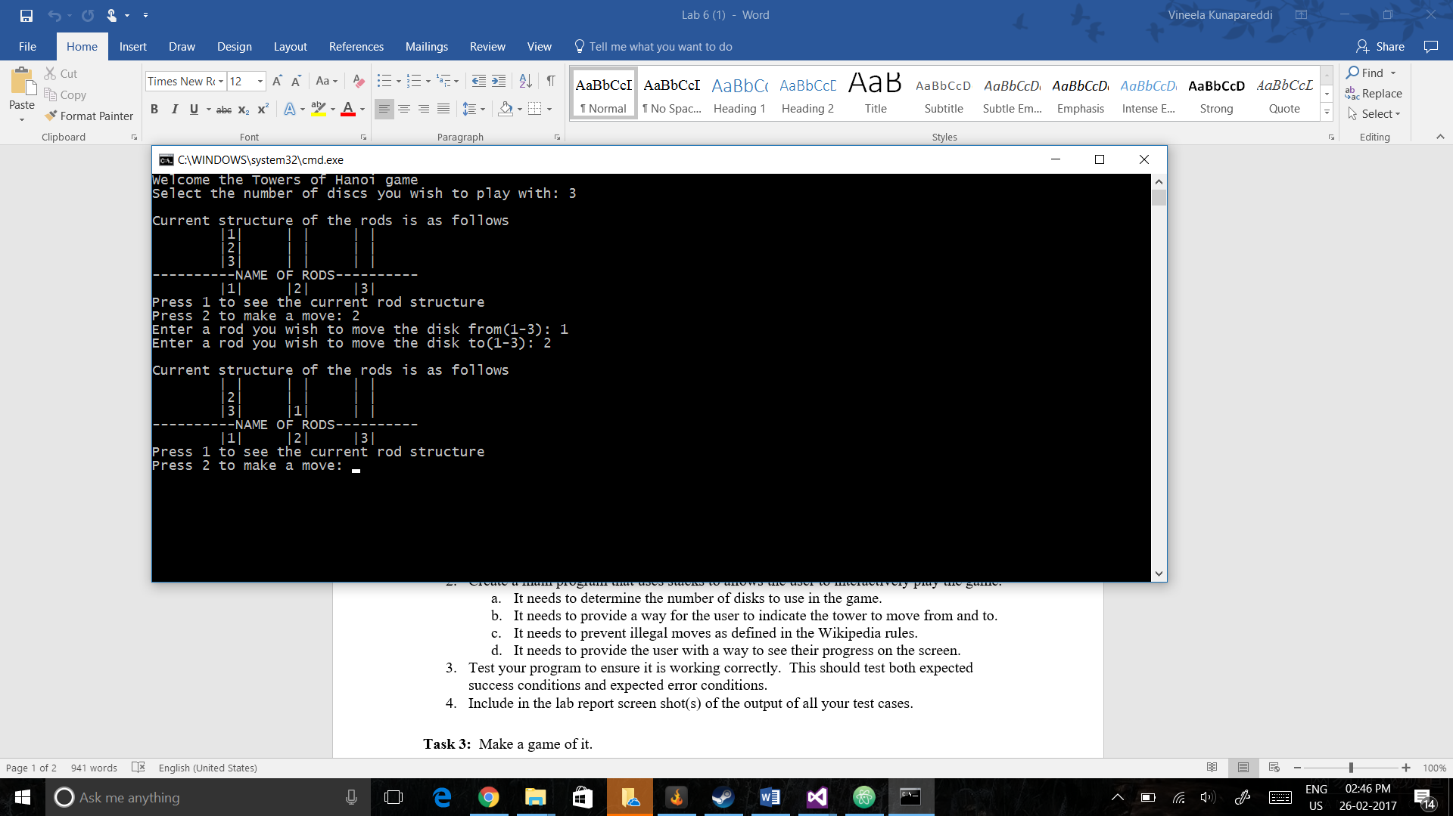

Screenshot of making an invalid move:

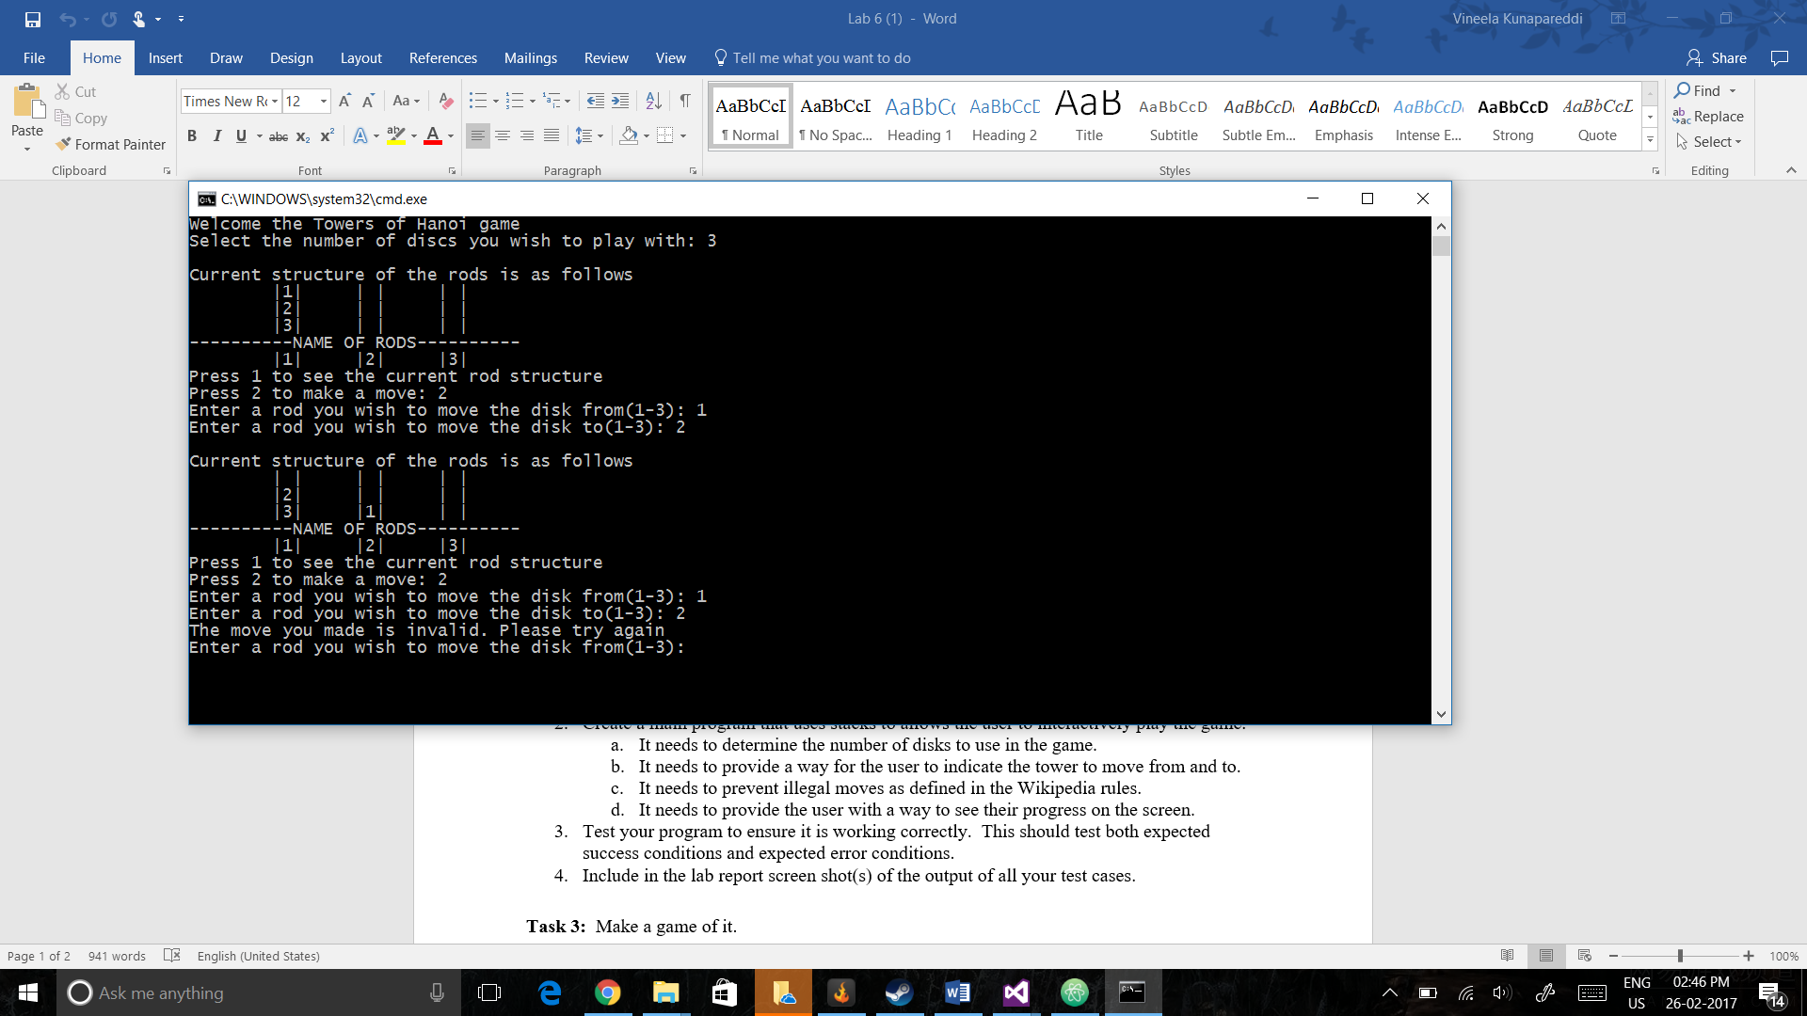

Screenshot of giving a way to view current structure of rods:

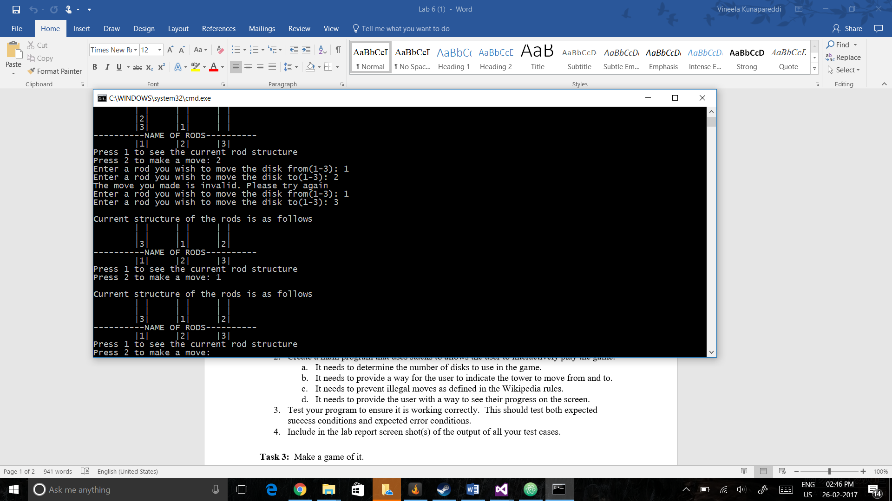

**Task 3:**

Screenshot of a victory in multiplayer:

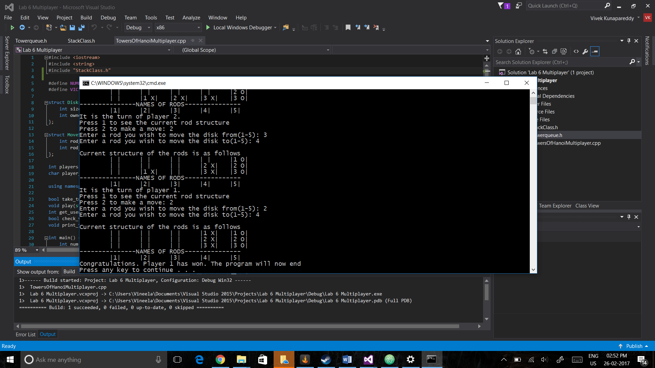

**Discussion of strategies:**

Initially when trying out the game, in our group we decided to ignore the other player while making sure our own disks end up on the other rods.

However when testing our edge cases we used a cooperative method to make sure we reached our edge cases.

**Task 4:**

Screenshot of queue of all moves:

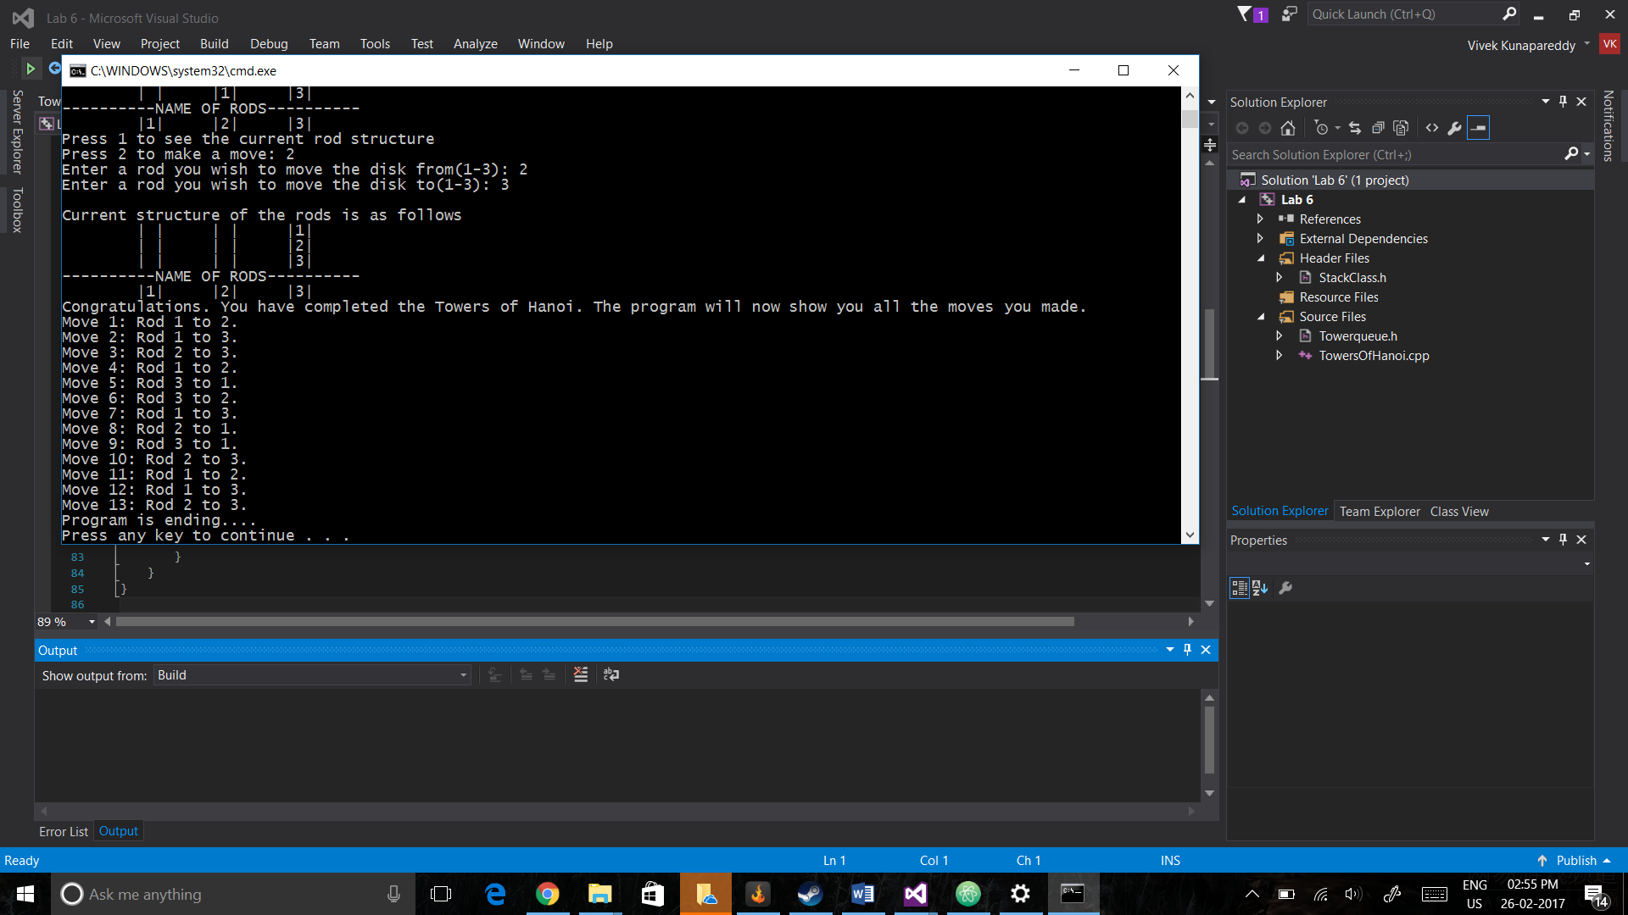

**Move structure:**

The move structure was defined to be just two integers encased in a struct. The two integers represent the rod from which the disk was moved and the rod to which the disk was moved as indexes in the array of the rods

**Instructions:**

Please enter only a single number at a time to ensure the execution of the commands

Task 4 was represented in the TowersOfHanoi.cpp file

**Group Contributions:**

All the programming was done together